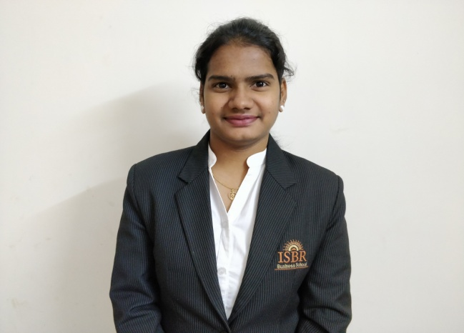 **RESUME**

**THANGELLA SOWKYA**

**Address:** H no: 204,5,block-a,

Keshaswini plaza,

Jyothi nagar, Hyderabad.

**Contact No:** +91-8341713170

**E-mail:**thangella.sowkya@gmail.com

**DOB :** 25-08-1995

**OBJECTIVE:**

My motive at this point of time is to learn and adapt to new technologies related to my profession, thus enhancing my innovation skills and making myself more profitable to the organization.

**SUMMER INTERNSHIP:**

**COMPANY:**  **INDIA BULLS**

* Have Collected Client’s data like their net portfolio, Relationship manager details, cash margin available and then need to save the data in Excel sheet.
* Made calls for around 200 Client’s and explained about Insurance Term plan.

**COMPANY: Edelweiss Broking ltd**

* Have generated 5 leads in Demat account opening in the period of one month.

**EDUCATIONAL QUALIFICATION:**

|  |  |  |  |  |  |
| --- | --- | --- | --- | --- | --- |
| **Examination** | **Discipline/ Specialization** | **School/college** | **Board/ University** | **Year of passing** | **%** |
| PGDM | Finance | ISBR Business School | AICTE | 2019 | Pursuing |
| B.COM | Computers | Osmania University College for Women | Osmania  University | 2016 | 86.9% |
| 12th | M.E.C | Sri Gayathri Junior  College(Hyderabad) | Board of intermediate  Education, AP | 2013 | 93% |
| 10th |  | MNR High School,  (Hyderabad) | SSC | 2011 | 87.3% |

**PERSONAL TRAITS:**

* Team work.
* Positive attitude.
* Adaptability.

**CERTIFICATION:**

* NISM Mutual funds
* Investment Banking

**TECHNICAL SKILLS:**

* MS Excel
* MS Powerpoint
* SQL

**WORK SHOPS:**

* Mind Management in Emotional Intelligence.
* Transactional Analysis.
* Women and Security.
* Participated in Work day Experience at ADECCO.

**CO-CURRICULAR ACTIVITIES:**

* Coordinated for TEDx ISBR Bangalore.
* Participated and organised college cultural fest.
* Volunteered for Formation day held in ISBR Business School.
* Coordinated Cultural club events in college.
* Volunteered for Rally for Rivers event.

**VOLUNTARY WORK:**

* Taught some ethics to children in Government School.
* Organized CSR event.

**HOBBIES:**

* Socializing
* Cooking
* Playing Badminton
* Browsing